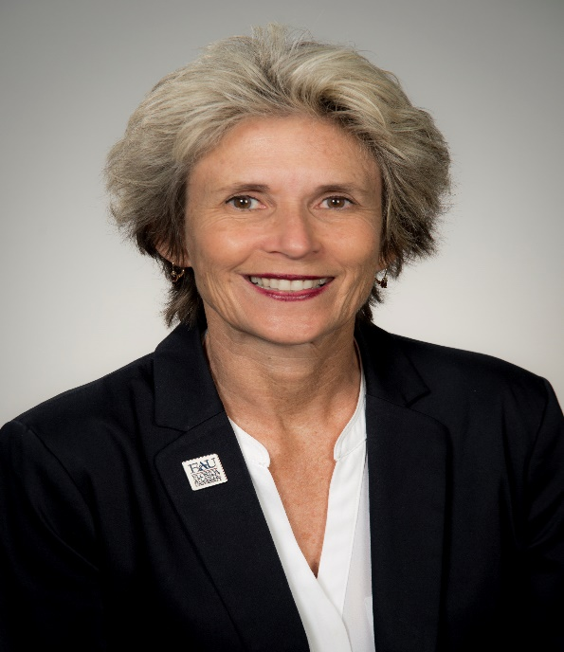

Laurie Carney, Senior Director of Development and Outreach: Major gifts officer at Florida Atlantic University (FAU) since December 1999 responsible for development activities within the Dorothy F. Schmidt College of Arts and Letters including annual, endowment, principle and legacy gifts.

Laurie works strategically in partnership with the Dean, University/College leadership and faculty to identify and inspire philanthropic opportunities to enhance FAU’s reputation of excellence and to support strategic initiatives.

Laurie worked in nonprofit organizations for 20 years prior to joining FAU in professional and management positions that included donor recruitment, fundraising, strategic planning, new business development, special events, and marketing.

Laurie is an FAU alumna with a Masters’ degree in Public Administration, and she holds a Bachelor of Science Education degree with a minor in music and emphasis in Therapeutic Recreation from the State University of New York College at Cortland. In 2013 she completed a one-year graduate level Chartered Advisor in Philanthropy (CAP) certification from the American College, Bryn Mawr, PA designed to facilitate inspired philanthropic planning and legacy gifts.

